SQL Project

Business model Customer to Customer (C2C) allows customers to do business with each other. This model is growing fast with e-commerce platforms where sellers may be required to pay some amount and buyer can buy it without paying anything. E-Commerce website brings the seller and buyer to the same platform.

Analysing the user's database will lead to understanding the business perspective. Behaviour of the users can be traced in terms of business with exploration of the user’s database.

Dataset: One .csv file with name users data with 98913 rows and 24 columns

**Tasks performed**

**1.)**

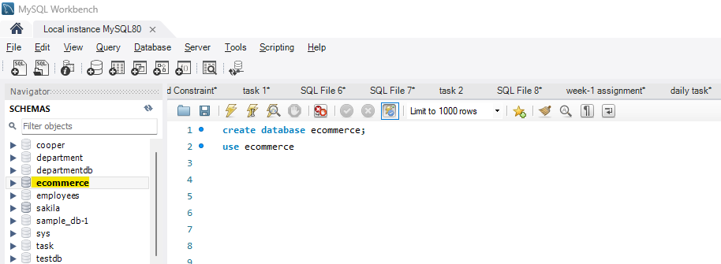

New database ecommerce is created

**2.)**

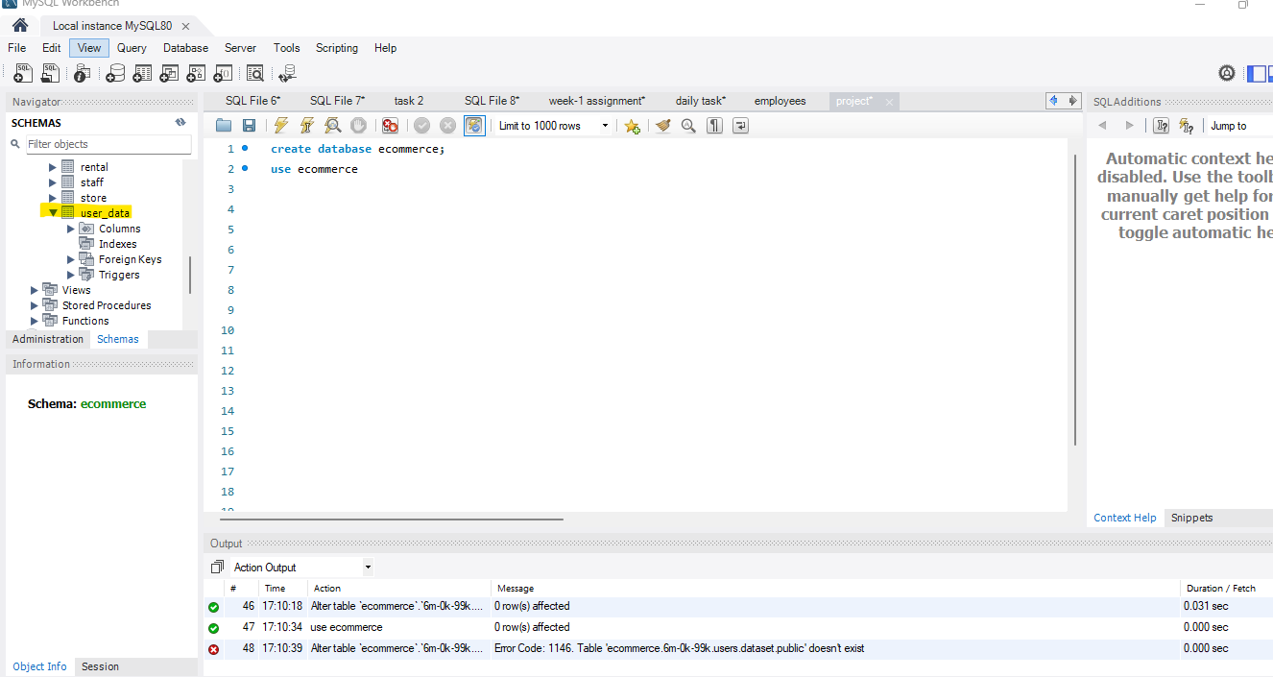

Table **user_data** has been imported

**3.)**

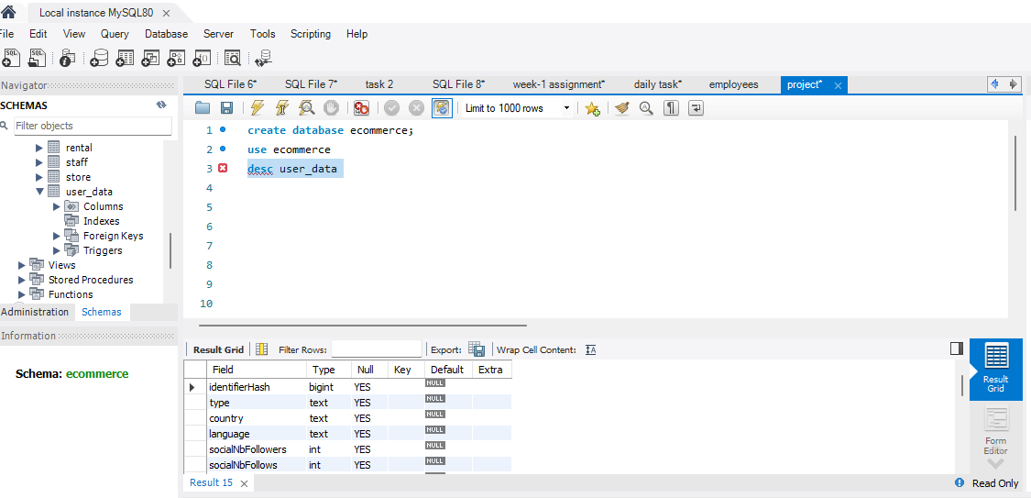

**4.)**

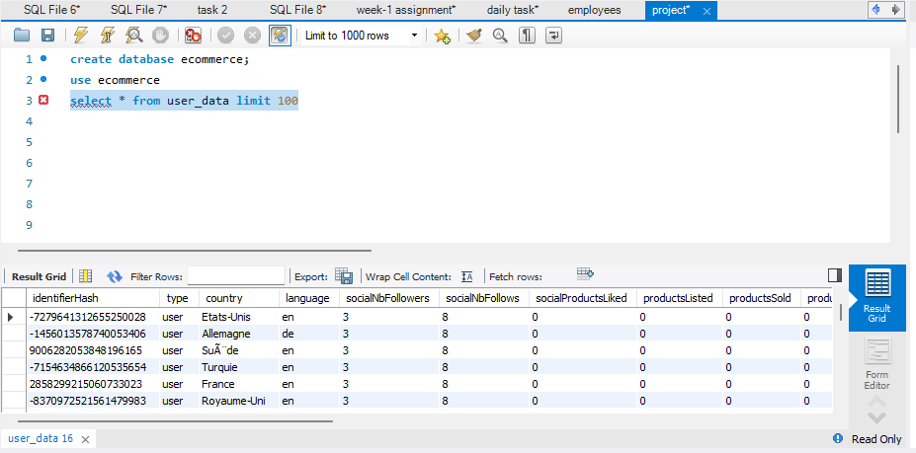

First 100 records have been displayed

**5.)**

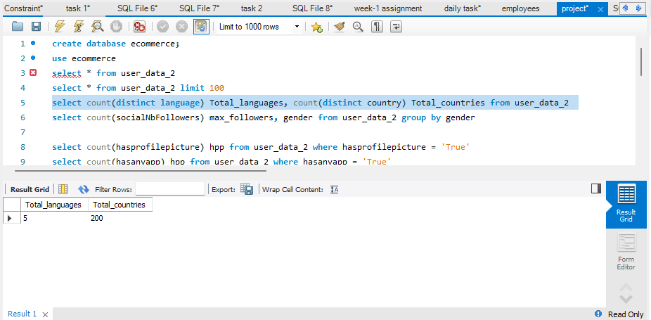

Count of total countries and languages

**6.)**

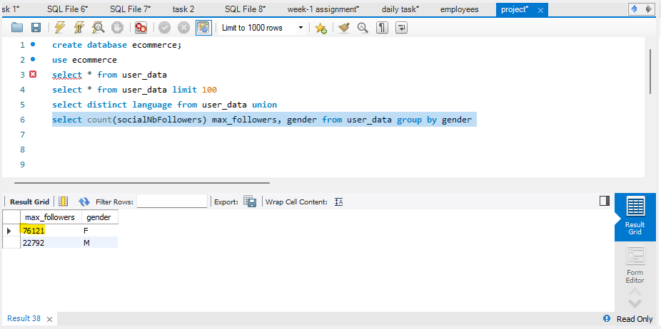

Checking which gender has maximum followers

**7.)**

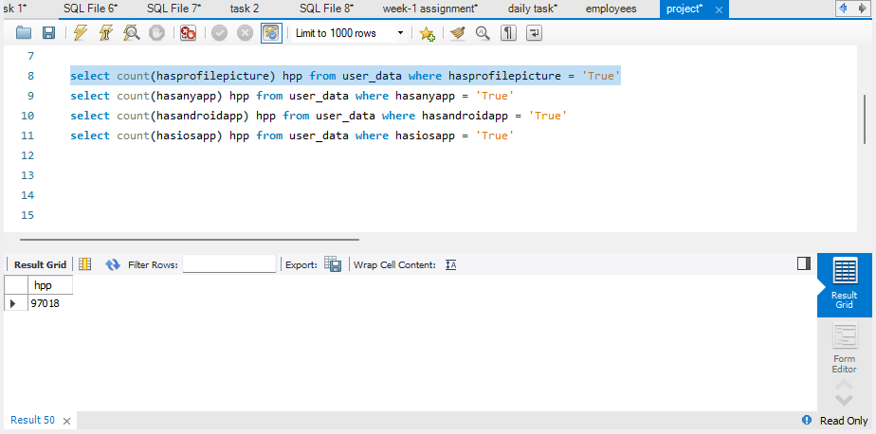

Count of users enabled profile picture

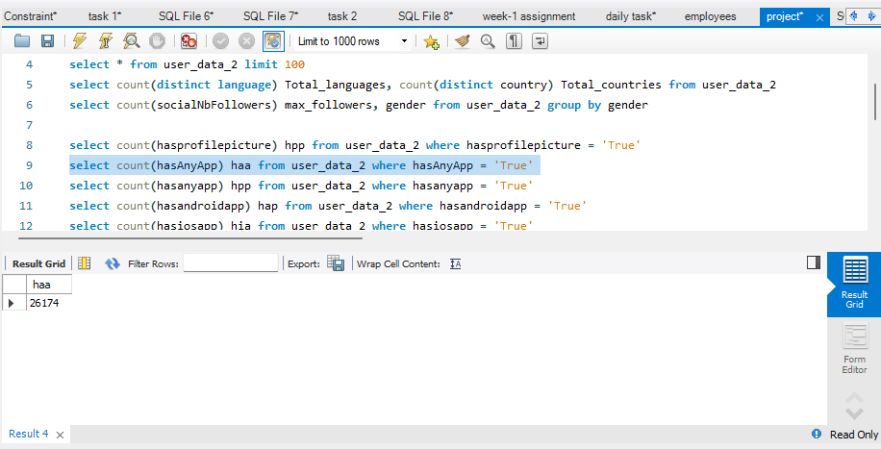

Count of users use ecommerce platform

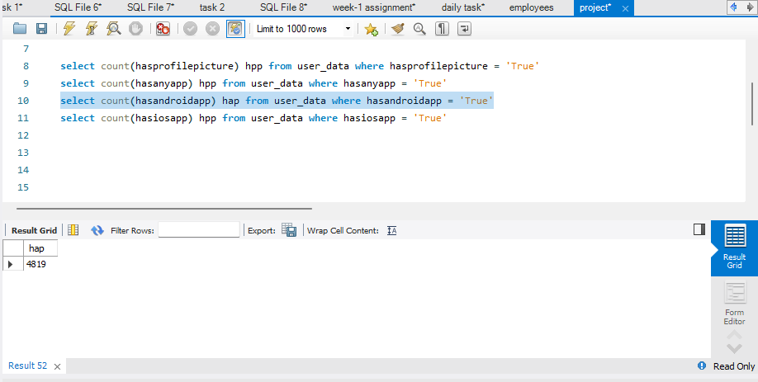

Count of users having android

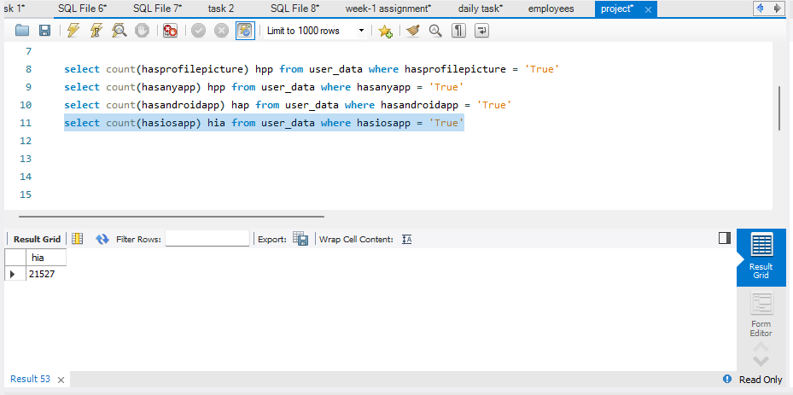

Count of users having ios

**8.)**

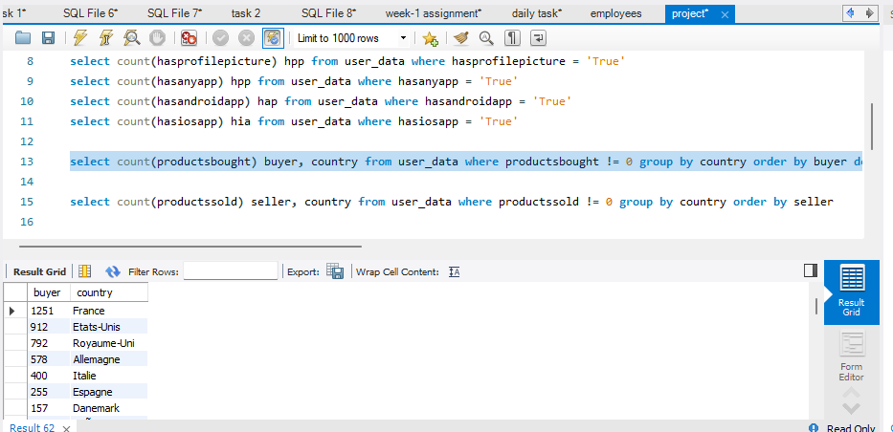

Buyers from each country

**9.)**

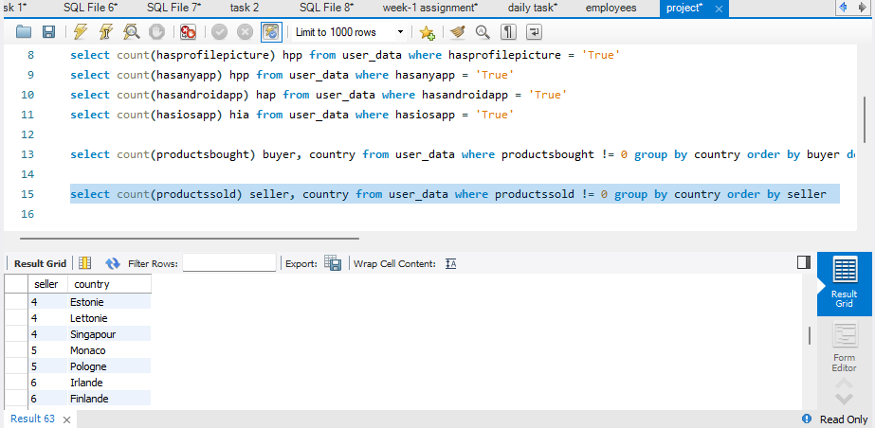

Sellers from each country

**10.)**

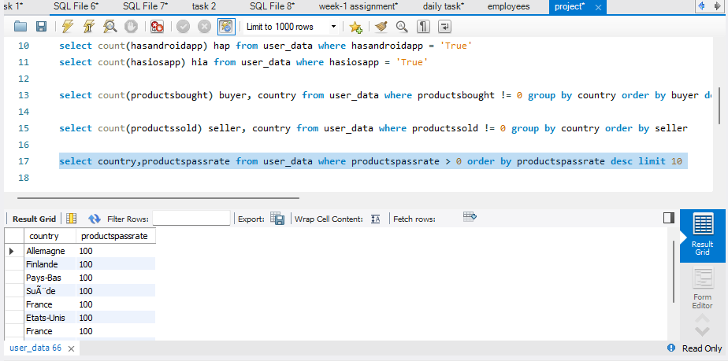

Top 10 Countries with highest product pass rate

**11.)**

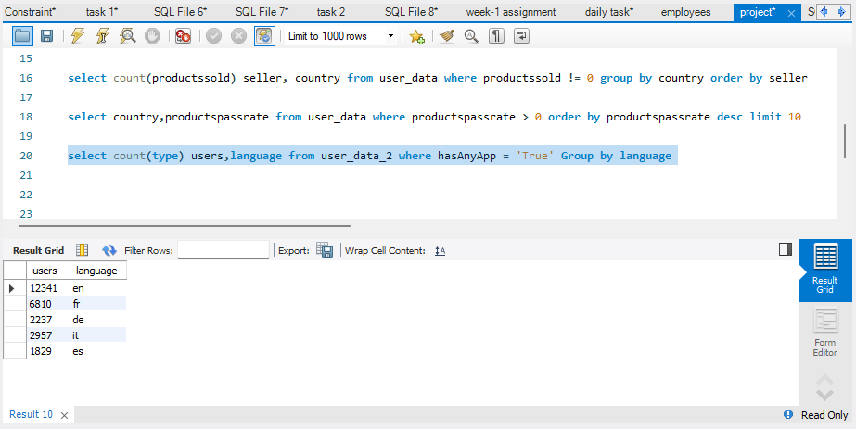

Number of users on ecommerce platform from different languages

**12.)**

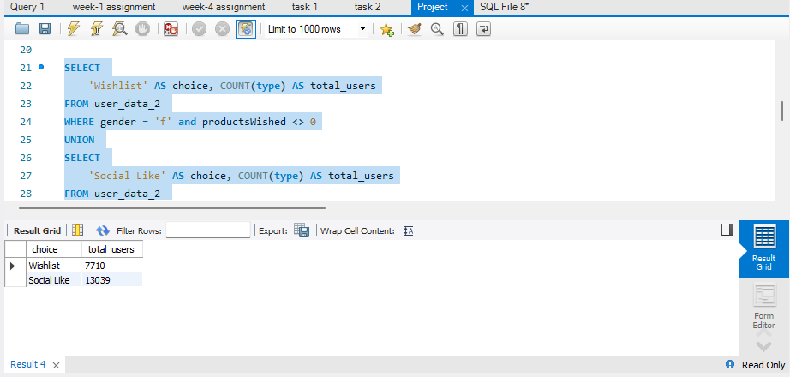choice of female users wish listed products and liked products in ecommerce platform

**13.)**

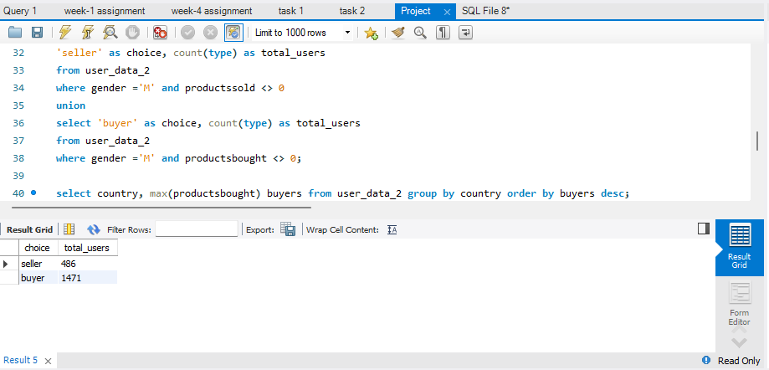

Choice of male users being seller or buyer

**14.)**

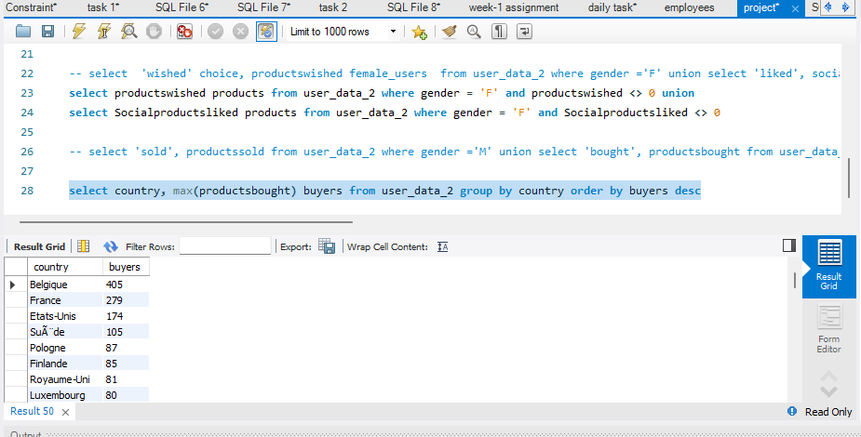

Maximum buyers from each country

**15.)**

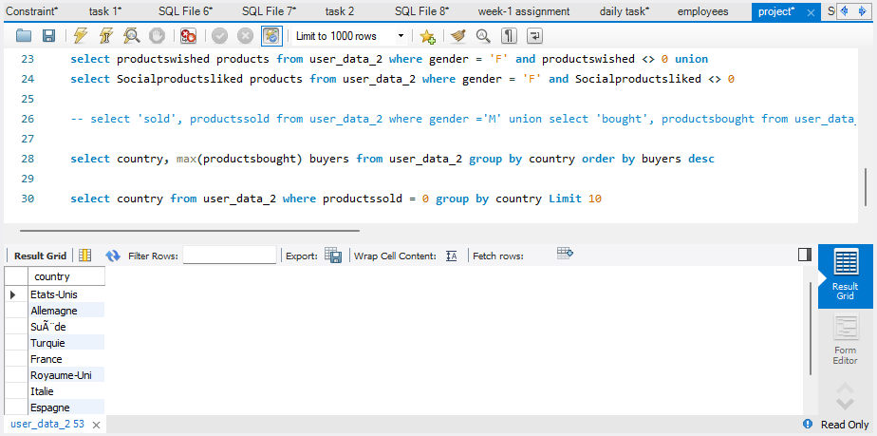

Top 10 countries with 0 sellers

**16.)**

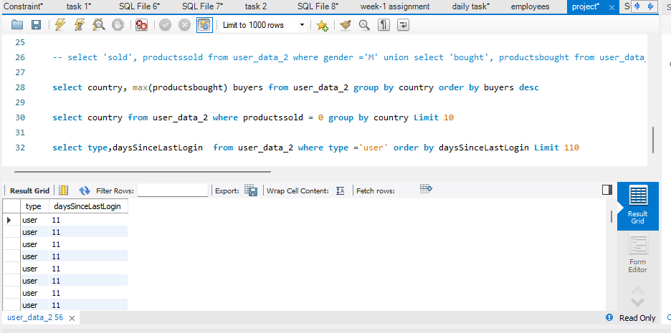

Top 110 users who have recent login to ecommerce platform

**17.)**

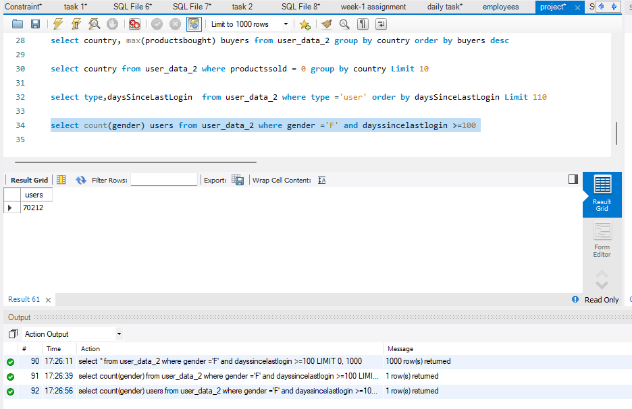

Female users who have not logged in for past 100 days

**18.)**

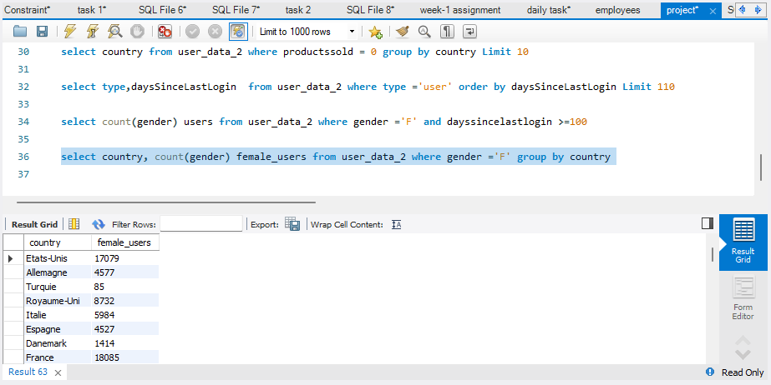

Female users using ecommerce platform from each country

**19.)**

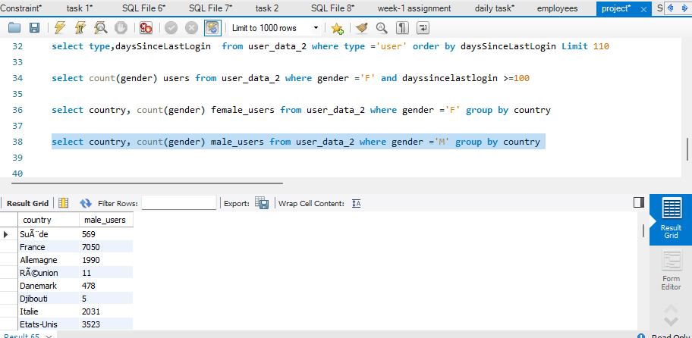

Male users using ecommerce platform from each country

**20.)**

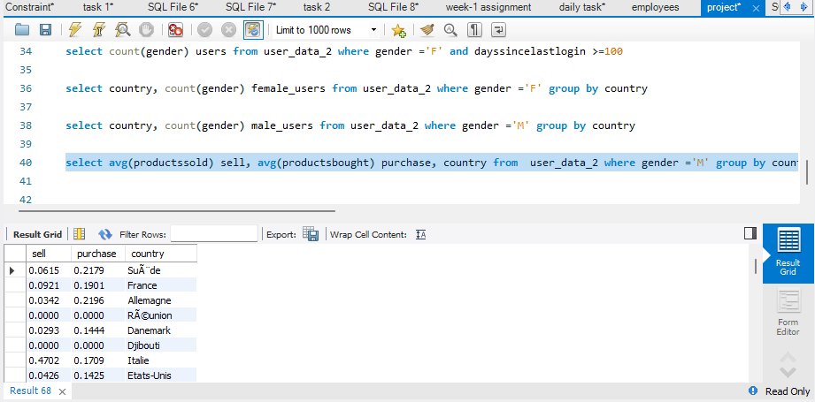

Average products sold and bought by male users from each country